**Name: Session:**

**Programming I**

**Lab Exercise 12/2/2022**

1. Write a program that generates 1000 random numbers (without duplicates – you could use a set) in the range of 1 to 10000. The program should then create two lists of those numbers which are Fibonacci and those that are Prime. Hint: create a list of Fibonacci numbers and use the isPrime function you have already written.
2. Do you like treasure hunts? In this problem you are to write a program to explore the above array for a treasure. The values in the array are clues. Each cell contains an integer between 11 and 55; for each value the ten's digit represents the row number and the unit's digit represents the column number of the cell containing the next clue. Starting in the upper left corner (at 1,1), use the clues to guide your search of the array. (The first three clues are 11, 34, 42). The treasure is a cell whose value is the same as its coordinates. Your program must first read in the treasure map data into a 5 by 5 array. Your program should output the cells it visits during its search, and a message indicating where you found the treasure.

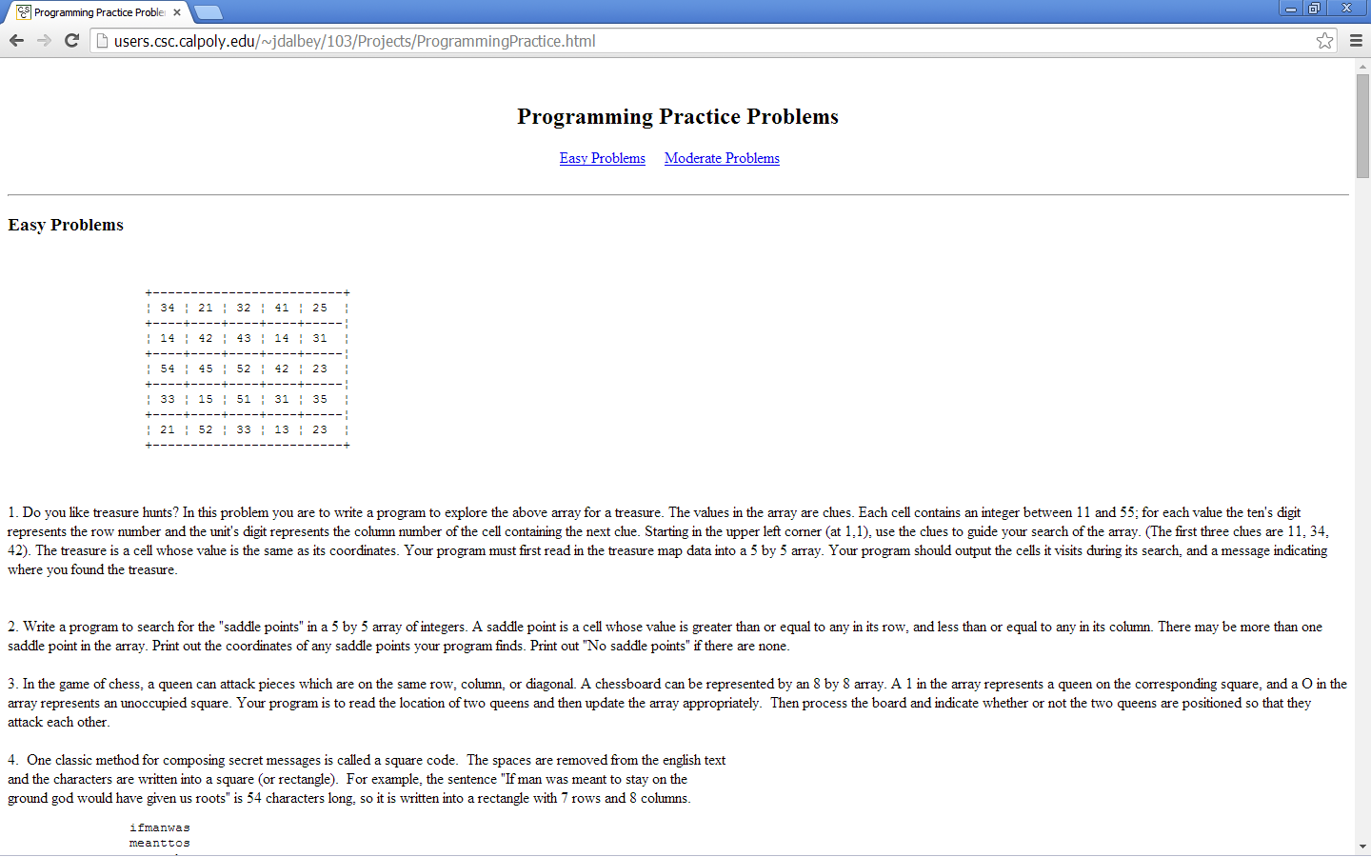

1. Many times people will use letters for a phone number such as 1-800-EAT-SPAM. Write a function that will translate this into a regular phone number. I recommend using a dictionary with the following mappings:

A, B, C → 2

D, E, F → 3

G, H, I → 4

J, K, L → 5

M, N, O → 6

P, Q, R, S → 7

T, U, V → 8

W, X, Y, Z → 9